1.0 Project Aim
The main aim for the project is to establish a Marine Protected Area (MPA) for the conservation of dugong and seagrass in bay of Brunei, Lawas, Sarawak East Malaysia, Thus the objectives for the project are as listed below:

- To contribute knowledge on dugong population ecology and seagrass to State and Federal Cabinet Meeting agendas.
- To contribute knowledge to the National Plan of Action (NPOA) for the conservation and management of dugong and seagrass in Malaysia.
- To develop capacity building on dugong and seagrass
- To involve local community in conserving dugong and seagrass

2.0 Expected outputs
- Filling knowledge gaps of dugongs in the Bay of Brunei specifically related to their distribution, abundance, behaviour and movement.
- State cabinet documentations to support the gazettement of an MPA for dugongs and their seagrass habitats.
- Knowledge and recommendations to decision makers to formulate/review dugong related policies and legislations to conserve dugongs and their seagrass habitats.
- Trained local researchers on dugong and seagrass survey methods.
- Involvement of local community and school children through Honorary Wild Life Ranger Program (HWLR) and Conservation Education and Public Awareness programs

3.0 Survey methodology
3.1 Dugong survey
Three type of drones or unmanned aerial systems (UAS) namely the Skywalker 2014 single rotor fixed wing (3 hour flying endurance), the fully autonomous Hexarotor (30 minutes flying endurance) and DJI Phantom 3 Advance are used for dugong survey area in Lawas, Sarawak, Malaysia (Figure 1).
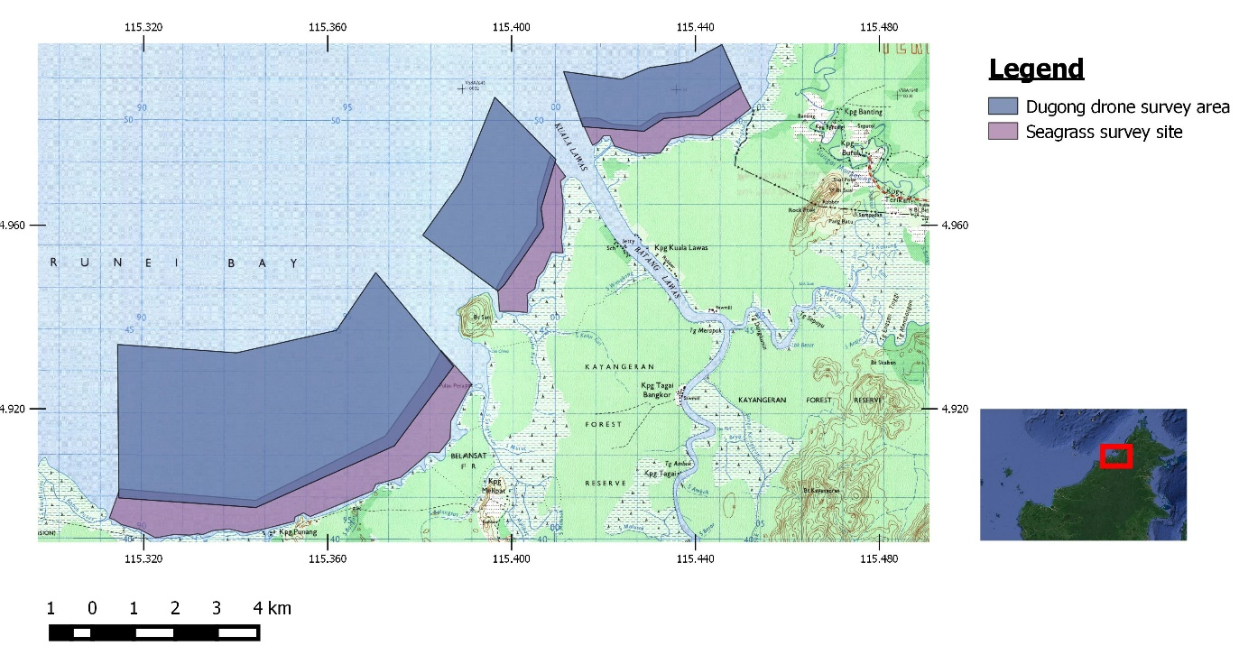
Figure 1: Drone survey areas

The trial for all UAS were successfully conducted from 13th Apr to 21 April 2016.
The main objective of the trial were:
- To find out the limitation and capabilities of each UAS
- To discover best working conditions for both of the systems
- To estimate best operation time for each system based on mission requirement for dugong and seagrass surveys.
Flight planning for the Skywalker and Hexarotor drones utilize the Mission Planner software which can be obtained online for free. The software enables autonomous mission by the UAVs uploaded into the Flight Controller on the UAV via mentioned software. Flight path planning duration, total distance, and flight time differ for both UAVs as both systems has different systems and endurance.

- Skywalker 2015 single rotor fixed wing
The skywalker drone is a long range system powered by 10,000 mAH battery with 3 hours flight endurance has the capability to cover a large area in a single mission. The mission elevation for the fixed wing was set at 70 m and 50 m elevation at speed about 12ms⁻¹ (43kmp⁻¹) (Figure 2).
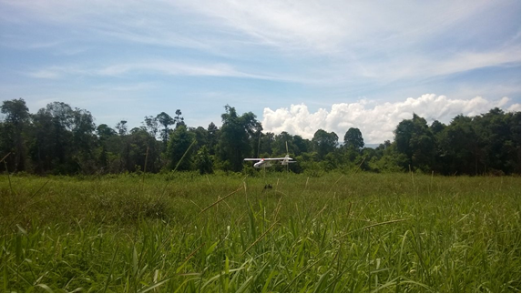
Figure 2: Skywalker drone landing after mission completed

The drone was paired with the Canon S100 camera (CHDK – Canon Hacking Development Kit enabled) with KAP UAV script running to enable auto capture of photos for every 2 seconds. The average battery life of the Canon S100 is about 1 hour continuous photo shoot. However for coastal survey that may require mission flights for about 2 hours, the camera endurance is insufficient. An upgrade to the battery endurance to achieve at least 2 hour continuous recording or another capable camera with endurance up to 2 hours (eg GoPro Hero 4 + Battery BacPac) specifically for coastal dugong survey.
The Skywalker planned flights varies from 30 to 300 minutes depending on size of area and distance of the survey area. The camera overlap was set to 0% in order to cover a wider area as the flight time is limited. The drone will autonomously return once the on board battery depleted to 14.4 volts.

- Fully autonomous Hexarotor
The hexarotor drone powered by 25,000 mAH Lithium Polymer rechargeable battery is used to record and observe dugongs live view during night time at their identified ‘hotspot’ area (determined using Skywalker drone or by ground truthing at their favorite feeding areas) using infra-red camera model TAU-640 (Figure 3).
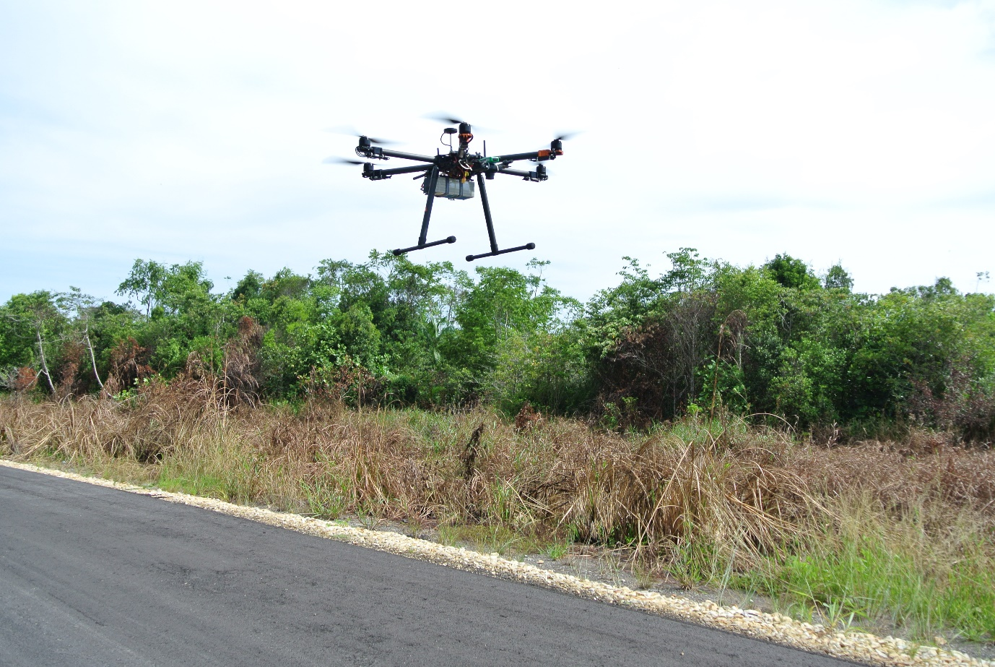
Figure 3: Hexarotor mid-flight during start of mission

The pre-planned survey area averages from 0.4 to 0.5 km² with average flight time of 25 minutes at speeds 5 ms⁻¹ (18kmh⁻¹) at an altitude of 50 meters. The hexarotor flight missions averaged about 20-25 minutes dependent on the mission or battery level. The drone will autonomously return once the on board battery depleted to 22.2 volts.

- DJI Phantom 3 Advance
The Phantom 3 Advance (P3A) was utilized mainly as the scouting drone for site reconnaissance in order to ensure the suitability for the drone operations (take-off, landing, landing approach, mission elevation, etc) (Figure 4)
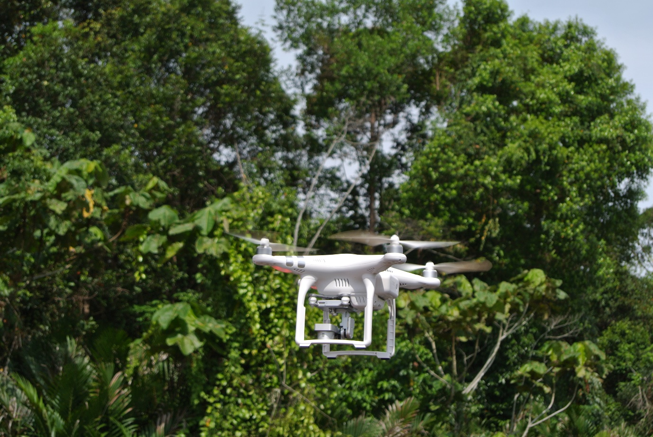
Figure 4: DJI Phantom 3 utilized for UAV take off site assessment

. Once the site was deemed suitable, both larger systems mentioned above can be safely deployed and utilized for missions.

3.2 Seagrass survey
The Skywalker drone was use to map seagrass meadows along the coastal area during the low tide (where seagras ses are exposed). The mission specification is the same as 3.1(a). The The photos from the survey will be stitched together to produce maps which later will be digitized using Quantum GIS. The seagrass area size from the map will be calculated and randomly sample for dugongs grazing trail and species composition temporally and spatially.

4.0 CEPA Materials and photos (Please refer to attachement)

