The GEF Dugong and Seagrass Conservation Project
Project Progress Report

Reporting Period | From: | July 2016 | To: | January 2017

- PROJECT GENERAL INFORMATION

National Project Code & Title: | MZ 4 - 2119: The Bazaruto Dugong Protection Project

Project Partner(s): | - The Bazaruto Archipelago National Park (BANP)  - Sitone Community  - Kanhi Kwedo and Thomba Yedho Community Associations  - Blue Ventures  - Dugongs.org  - IUCN  - African Parks  - The National Directorate of Conservation Areas, Mozambique (ANAC)  - Ministry of Land, Environment and Rural Development (MITADER)

Location (country, region/ district and commune/ city/ village/ region etc.) | Mozambique- Inhambane Province, Districts of Vilankulo and Inhassoro, Bazaruto Archipelago National Park.
Of which areas under protection (please indicate the name and size of protected areas or locally managed marine areas, if applicable) | The Bazaruto Archipelago National Park (created in 1971) which measures 1430 Km²

Project start date | 2015-08-01 | Project intended completion date | 2018-09-30

- PROJECT PROGRESS

  - Narrative of project progress during the past semester by Project Activity

Since the last report, we carried out a number of community focus groups in order to understand better where the communities were coming from, what were their main challenges and to gain further insight into the relationships that the community members have with their natural resources – specifically with the marine environment. What stood out, over and above the numerous challenges that communities face due to lack of access to basic services, was that the ocean was the most important commodity available to the communities. Community members expressed their love and respect for the ocean, and the need that they have for the ocean to feed them. See the image below for a design made during one of the focus groups.

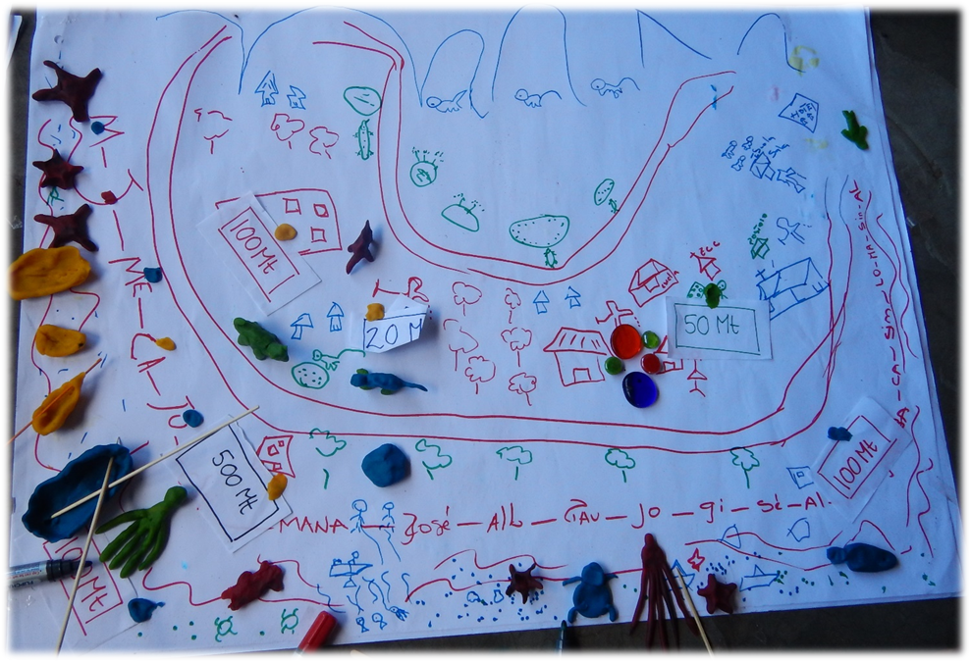
Dunes
Reserve area
Farm
Red duiker
Bore hole
Market
Church
Boats
School
Thomba Yedhu and Clinic
Fisher camps
Road
Transport Boat

Community focus group, participative design process

While a conservation organisation cannot hope to address the lack of basic needs that the community members on Bazaruto Island are lacking, we are able to assist with improved management of the marine resources on which the communities so heavily rely. We subsequently began working with the fishers to understand further the current fisheries management system and see if it could be made more effective. At the moment, the fishers agree amongst themselves on a few months a year when the seine netting fishery is closed. However, this closure is not based on any robust data and there are often arguments between fishers as to when the optimum closure should occur. Fishers were enthusiastic to get involved in monitoring their catch and to figure out a way to improve their catch while not depleting the fish stock so much that their grandchildren would have no fish. Fishers also expressed the wish to develop alternative methods of fishing, improve the processing of fish and access to markets.

This outcome from the focus groups was very positive as it demonstrated that the fishers were wanting to manage and care for the marine resources and was seen as a good access point to gaining the trust of the community

A fish monitoring application – a step towards a sustainable fishery

We collaborated with the fishers who want to improve the status of their fishery and co-developed and piloted a smart phone application with which the fishers could begin to record their fishery data and discuss the patterns that emerged. This had a very positive outcome and can be used as a management incentive in much the same way that alternative livelihoods are used as incentives for change. During the development of this application, Isabelle, accompanied by the president of the Bazaruto Fishers Association, attended a workshop in Cape Town, with fishers and NGOs from a number of countries where small-scale fishing is important (including representatives from Madagascar, Tanzania, Trinidad and Tobago and Seychelles). This was extremely beneficial for the fishers as it provided a platform for discussions on fisheries management at the small-scale level and discussed the tools available for this. Another outcome was the network of fishers that came together during these three days.

There are many offshoots from the use of an application such as the fish catch landings application that we developed. A few of them:
- Identify the most commonly caught fish and monitor their changes
- Use the information in a visual way in order to discuss sustainable and non-sustainable fish catch
- Link sustainable fish catch with markets via the use of smartphones

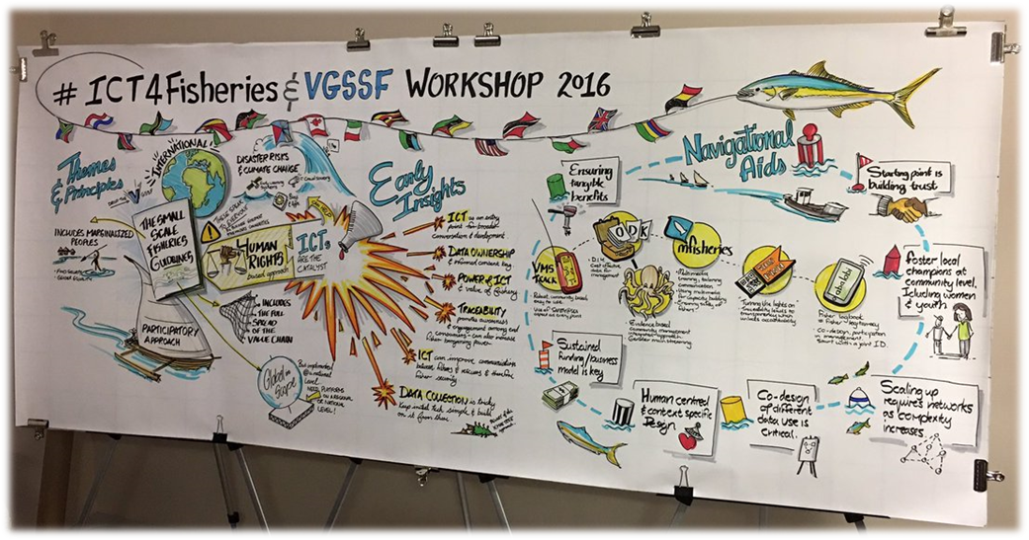

The use of smartphone applications in fishery management

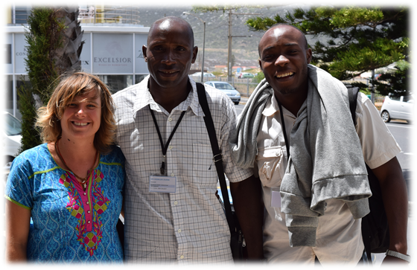

Isabelle Giddy, Crimildo Zivane and Sacramento at the ICT4Fishers workshop

Alongside research and tool development for a sustainable fishery, we have been working on the development of additional livelihoods as management incentives. This is addressed in the MZ1 report.

Challenges

While the project has seen some successes, it has also experienced a number of challenges in its implementation. These range from logistics and accommodation difficulties and lack of staff capacity to challenges in communication and misguided expectations with the fishers at times as well as the park management. The project coordinator has also resigned and thus a significant challenge in the project implementation is faced.

From next year, African Parks will be taking over management of the Bazaruto Archipelago National Park. In the light of this change in management and the resignation of Isabelle Giddy, EWT will step away for a few months in order to assess needs and discuss how EWT can most effectively play a role within the new management system. The information gathered over this past year will be used by all stakeholders to inform decisions made into 2017.

  - Project implementation progress

Outputs & Activities [1] | Expected completion date | Implementation status as of end of reporting period | Describe any problems in delivery and any changes/mitigation action required.
Outputs & Activities [1] | Expected completion date | expressed in %
Output 1.1: Governance structures for community involvement in conservation and monitoring of dugong and seagrass ecosystems established or strengthened in target areas
Activity 1: Create the Bazaruto Conservation Forum and invite all relevant stakeholders to become members- including Community Leaders and CCP's | June-17 | 30 | The need for a Bazaruto Conservation Forum has been expressed by various stakeholders in and around the archipelago. This is on hold until African Parks takes over management as AP is in a better position to facilitate the forum
Activity 2: Elect representatives from each Sector/ stakeholder group to act as spokesperson. | Jul-16 | 80 | A thorough stakeholder map has been put together. Representatives will be elected closer to initial meeting
Activity 3: Convene quarterly Bazaruto Conservtion Forum meeings. | Jun-17 | 0 | The BCF has been changed to the Bazaruto Conservation Forum, after consultation with stakeholders. No meeting has been held yet.
Output 2.1: Management and incentive mechanisms and tools for sustainable fisheries – pilots and capacity building (local community and government)
Activity 4: Perform market-related research for sustainably-caught fish (using hand line at FADS and other designated fishing grounds), and secure buyers for SSI produce. | Jul-17 | 10 | No progress this sector.
Activity 5: Analyze livelihood interviews to select candidates that are eligible to trial the SSI initiative. | July-16 | 100 | Following further community focus groups we found the need to develop a way in which to involve the fishers in management and conversations about sustainable fisheries. We began working on the development of a fish catch recording app, using ODK Collect.
Output 2.2: Awareness raising and social marketing programmes contributing to more sustainable practices (subsistence and small-scale artisanal fishers) in target areas
Activity 6: Communicate all Project highlights and progress on Social Media (Joint Project Facebook Page- All National Projects) | Sep-18 | 0 | Project highlights have been posted on the EWT Facebook page, however updates need to be shared with the joint group page more often.
Activity 7: Collate existing material to develop the marine-themed environmental education lesson plans and worksheets. | Apr-17 | 40 | EWT has met with other country partners, Dugongos.org to consolidate all teaching materials and this will only be ready in 2017. EWT has also met with MMF who are also implementing marine themed lessons on the island.
Activity 8: Identify teachers (mostly women) at all Vilankulo, Inhassoro, and Island Schools who are interested in/ responsible for teaching natural sciences. | Apr-17 | 10 | EWT has met with schools on the islands but not with mainland schools yet.
Output 3.1: Critical knowledge gaps (dugongs and seagrass ecosystems) identified and surveys initiated/ completed
Activity 9: Determine available sustainable fish stocks in the Bazaruto Archipelago National Park- pelagic species - and unsustainable species | Jul-17 | 30 | We have begun trialling the use of BRUVs (Baited Remote Underwater Video) to determine diversity and abundance changes over time in key areas. We have not yet implemented this but the sampling strategy and methodology has been developed. This has been developed in consultation with Anthony Bernard from the South African Earth Observation Network (SAEON). It is hoped that a student will be sourced for this research.  We have also collaboratively developed and trialled a fish catch monitoring application for smart phones along with the Bazaruto Fishers Association and selected fishers from each village in Bazaruto.
Output 3.2: Good practice guidelines for dugongs and seagrass ecosystems conservation developed from project experience
Activity 10: At DPU meetings: (a) Coach members to implement appropriate actions for reporting procedures of Dugong sightings, gill net sightings, and Dugong mortality, (b) Set clear and achievable reporting and procedure guidelines, and (c) Develop best-practice guidelines for relevant legislation and fisheries policy instruments. | Jun-2017 | 0 | The Bazaruto Conservation Forum is yet to be officially established in communication with African Parks

  - Risk and risk management
Please describe internal and external risks (examples included in brackets) that could affect successful implementation of project activities and the proposed risk mitigation measures.
Risk group | Description | Risk level (Low/ Medium/ High) | Mitigation measures
Project Management (team capacity, internal communication, co-financing, budget, financial management, reporting, etc.) | We are experiencing challenges with human resources and capacity | Medium | Our project coordinator has resigned and we are busy re-evaluating our project design and implementation strategies
Socio-cultural issues  (external communications, capacity of and work with stakeholders, cultural aspects) | We have experienced significant challenges working with stakeholders due to false expectations that the fishers and the park respectively have of our role in the area. We have also experienced difficulties amounted due uninformed assumptions made because of cultural differences. | Medium | Make attempts to integrate with and understand the stakeholders as much as possible.
Political risks  (Political stability in country, political impacts on the project) | At present, Mozambique is fairly unstable. Many parts of the country are experiencing significant unrest; however Bazaruto has not been affected. | Low | Should civil unrest occur in our area, our project coordinator will return to South Africa for that period.
Environmental risks  (severe weather events/ disasters, natural causes negatively affecting project areas, habitats and species) | Tropical cyclones are known to affect the coast of Mozambique at 7-year intervals. The last Cyclone occurred in 2007, and another Cyclone is certainly expected during the Project timeframe. The intensity of the cyclone will determine the level of impact on the Project, and may cause delays of up to 2 months. | Medium | Cyclone detection can be made at least 10 – 7 days prior to the event, and a Cyclone’s track can be followed and predicted using online weather forecasts (Joint Typhoon Warning Centre). In the event of a Cyclone warning, the project will have ample time to take the necessary precautions and to stow away any Project material that may be affected by the adverse weather.
Other (please specify)

- MONITORING AND EVALUATION

  - Please describe activities for monitoring and evaluation carried out during the reporting period.
Examples include: baseline data collection, stakeholder surveys, field surveys, steering committee meetings to assess project progress, peer review of documentation to ensure quality, mid-term review, etc.
Do not include routine project reporting.

None so far. Project reflections and lessons learnt document to be completed and submitted by the end of January.

- OTHER INFORMATION

  - Meetings

 | Meeting type | Title | Venue | Dates | Convened by | Organised by | No. of participants | Report issued Y/N | Language | Dated
1 | Fisher Meeting | ICT4Fisheries | Fishhoek, Cape Town | 7-10 Nov 2016 | Serge Raemaekers | WIOMSA, UCT and Blue Ventures | 55 | Y | ENG | Nov 2016
2 | Fisher Meeting | Introduction of Fisher App in Bazaruto | Thomba Yedhu, Zenguelemo | 11 Oct 2016 | Isabelle Giddy | EWT | 3 | N
3 | Fisher Meeting | Follow up on Fisher App | Thomba Yedhu, Zenguelemo | 18 Oct 2016 | Isabelle Giddy | EWT | 6 | N
4 | Fisher Meeting | Follow up and feedback on fisher app | Thomba Yedhu, Zenguelemo | 20 Nov 2016 | Isabelle Giddy | EWT | 6 | N

  - List(s) of meeting participants

No. | Name of participant | Nationality
1 | Isabelle Giddy | South African
1 | Crimildo Zivane | Mozambican
2 | Isabelle Giddy | South African
2 | Crimildo Zivane | Mozambican
2 | Carlos Zivane | Mozambican
3 | Isabelle Giddy | South African
3 | Crimildo Zivane | Mozambican
3 | Carlos Zivane | Mozambican
3 | Manito Nhadave | Mozambican
3 | Faztudo Mazelete | Mozambican
3 | Nelson Zivane | Mozambican
4 | Isabelle Giddy | Mozambican
4 | Crimildo Zivane | Mozambican
4 | Carlos Zivane | Mozambican
4 | Manito Nhadave | Mozambican
4 | Faztudo Mazelete | Mozambican
4 | Nelson Zivane | Mozambican

  - Documents, other printed materials, videos, and soft products (such as CDs or websites)

No | Type | Title | Author(s) Editor(s) | Publisher | ISBN | Publication date
1 | Report | Collective Community Sculpting: Understanding community structure on Bazaruto | Isabelle Giddy (Au), Urszula Stankievicz and Lionel Massicane | N/A | N/A | N/A
2 | Report | Seaweed mariculture in Bazaruto Archipelago: Environmental, Economic and Social considerations | Isabelle Giddy (Au) | N/A | N/A | N/A
3 | Report | ICT4Fisheries: Responsible small-scale fisheries management and its relevance to Bazaruto | Isabelle Giddy (Au), Crimildo Zivane | N/A | N/A | N/A

Name of Project Manager: Isabelle Giddy |  | Name of Project Manager Supervisor: Bridget Corrigan
Signature: | Date: | Signature:  | Date:  10 January 2017

Briefly describe progress made during the previous six months highlighting major outcomes/benchmarks achieved during the period.
Information provided in “Quarterly Expenditure Report” should be in line with output/activity progress reported in this table.
O
Expand table as necessary
Expand table as necessary
Documents and printed material types: e.g. technical publication, meeting report, technical/substantive report, brochures, media releases, etc.

