BRIEF USER GUIDE
Virtual Repository of the Dugong and Seagrass Conservation Project
Version: 09 Oct 2016

- Why a virtual Project repository?
The virtual repository is an element of the heritage of the GEF Dugong and Seagrass Conservation Project. It has been developed to facilitate sharing of information between the Project Partners and the Project Coordination Team (with the Mohamed bin Zayed Species Conservation Fund), the CMS Dugong MoU, the Project GEP/ UNEP Task Manager and the reviewers of the Project at mid-term and end of the Project. The virtual repository will be used for internal communication. The Project website and social media will continue to form the platform for external communication.
The virtual repository has been opened using www.dropbox.com and will hold all the information on the Project, on a global and national level, including historical information about the Project at Project Preparation Grant phase (PPG, 2013), inception phase (2015) and subsequent progress of the Project until the end of the Project.
The virtual repository was developed by the Project Coordination Team (PCT) and will be maintained by PCT and selected members of each Partner. For convenience, PCT has uploaded all the available Project information on the virtual repository, for each country and each national project. As of the date of this guideline document, the virtual repository contains information on national project proposals and their progress, financial and technical, and supporting documents, cash advance requests, important correspondence, geographic references of Partners’ pilot sites, Partner’s contacts/ teams, as shared with the PCT until 30 June 2016.
The virtual repository was launched in October 2016 – an e-mail to all Partners in each country was sent on 5-6 October 2016 with a link to the repository for the respective country; selected team members of each Partner were contacted directly via Dropbox, assigning them editing rights. This was only the start of the virtual repository. Build the Project virtual repository is a continuous process, which needs support from all Partners of the GEF Dugong and Seagrass Conservation Project.
- What is this document about?
This a living document, which aims to provide initial guidelines on the use of the virtual repository of the GEF Dugong and Seagrass Conservation Project. As the repository develops and all Partners start using it on a daily basis, more questions will arise, helping the PCT elaborate further on the repository and improve everyone’s understanding of it.
- Where is the virtual repository located?
The virtual repository is located on Dropbox, www.dropbox.com . PCT shared with all Project Partners a link to their country folder, as shown in Table 1.
Table 1. Dropbox links to Project countries folders
Country | Dropbox link
Indonesia | https://www.dropbox.com/sh/ndjm2hk2ovglhar/AABSilSHftUDp3rMRSZ_CkuDa?dl=0
Madagascar | https://www.dropbox.com/sh/2sbx767etgzegs9/AACi8zwyxNd9D-Lw9_-q9Rf1a?dl=0
Malaysia | https://www.dropbox.com/sh/ogm6egmsm54gmvr/AADgPjXiTsvELP8L2zCvGg5ya?dl=0
Mozambique | https://www.dropbox.com/sh/osmleipydvksz39/AACkGegfBbsA4_yKxe5k512Qa?dl=0
Solomon Islands | https://www.dropbox.com/sh/zr4fbd4sn6kow8w/AACsn5KdSlD2jhd8WNHCT09Ka?dl=0
Sri Lanka | https://www.dropbox.com/sh/mi5xspakd1rmc28/AAC-isrEeaQhF5uh-eB5ZDcia?dl=0
Timor-Leste | https://www.dropbox.com/sh/c7gp4szuzipygfs/AAAbLK9JQFp6Q4N2NNOwjwd4a?dl=0
Vanuatu | https://www.dropbox.com/sh/n96lzdn02mzv2do/AAAxN7URkKEiQ88uqhD2-up-a?dl=0
The links in Table 1 allow for users (holders of the link) to access and download the information from the country folders. These users do not have editing rights. However, the PCT has provided editing rights to selected team members, as descried later in this document.
- Who should use the virtual repository?
The virtual repository should be used by all Partners of the GEF Dugong and Seagrass Conservation Project, who are charged with implementing a national project. All these Partners were invited to access to their country folders (ref. e-mails dated 5 and 6 Oct 2016). With this invitation these partners are now able to see the folder of their individual project. Editing rights were assigned by PCT to selected team members of the Partners, as listed in Table 2 below.
Table 2. Partners’ team members with editing rights
Country | Project ID | Partner’s team member with edit rights
 |  | Name | E-mail
Indonesia | ID1  ID2  ID3 | Casandra Tania  Erina Nelly | ctania@wwf.id  erinelly@yahoo.com
Madagascar | MG1 | Frances Humber  Victoria Jeffers | fran@blueventures.org  victoria@blueventures.org
 | MG2
 | MG3 | Patricia Davis | patricia@c-3.org.uk
 | MG4 | Isaia Raymond  Yvette Razafindrakoto | isaiaraymond@gmail.com  razafyve@yahoo.com
 | MG5 | Rijasoa Fanazava | rijafanazava@yahoo.fr
 | MG6 | Alison Clausen | aclausen@wcs.org
Malaysia | MY1 | Izarenah BT MD Repin | izarenah@nre.gov.my
 | MY2 | Syed Abdullah Syed Abdul Kadir | syedjohor@gmail.com
 | MY3 | Leela Rajamani | leelarajamani@gmail.com
 | MY4 | Louisa Ponnampalam | louisa.ponnampalam@gmail.com
 | MY5 | James Bali  Toloy Keripin Munsang | jjames71b@gmail.com  fox.toloy@gmail.com
Mozambique | MZ1 | Laura Robson  Frances Humber  Victoria Jeffers | laura@blueventures.org  fran@blueventures.org  victoria@blueventures.org
 | MZ2 | Vic Cockcroft  Alima Taju | vic@dugongs.org  alima.taju@gmail.com
 | MZ3
 | MZ4 | Bridget Corrigan | bridgetc@ewt.org.za
 | MZ5  MZ6 | Anselmo Gaspar | anselmogaspar@yahoo.com.br
Solomon Islands | SB2 | Corzzierrah Posala | kulo.buru@gmail.com
 | SB3 | Delvene Boso | d.boso@cgiar.org
 | SB4 | Senoveva Mauli | saemauli007@gmail.com
 | SB5 | Chrisanto Daokalia | chrisantod88@gmail.com
Sri Lanka | LK1 | Ranil Nanayakkara | ranil@bearsl.org
 | LK2 | Lakshman Peiris | lakshman_peiris@ymail.com
 | LK4 | Arjan Rajasuriya | arjan.rajasuriya@iucn.org
 | LK5 | Vasantha Pahalawattaarachchi | vasalanka@gmail.com
 | LK6 | Prasanna Weerakkody | prasannaweerakkody@gmail.com
 | LK7 | Thushan Kapurusinghe | kjthushan@yahoo.co.uk  tharangawildlifeart@gmail.com
 | LK8 | Lakshman Peiris | lakshman_peiris@ymail.com
Timor-Leste | TL1 | Trudiann Dale | tdale@conservation.org
 | TL2 | Greg Duncan  Frances Humber  Victoria Jeffers | fran@blueventures.org  victoria@blueventures.org
 | TL3 | Trudiann Dale | tdale@conservation.org
 | TL4 | Aires A. Guterres | aires_g@yahoo.com
 | TL5 | Augusto Pinto | ano.pinto@gmail.com
Vanuatu | VU1 VU2 | Christina Shaw | seashawconservation@gmail.com
In order to activate their editing rights, the Partners’ team members who have been assigned editing rights, should accept the invitation to join the Dropbox as sent by the PCT through the Dropbox.
- What is in each country folder?
In this Dropbox folder structure there are eight country folders (Indonesia, Madagascar, Malaysia, Mozambique, Sri Lanka, Solomon Islands, Timor-Leste and Vanuatu). In each country folder, there is a folder for each project (e.g. Indonesia: ID1, ID2 and ID3) as well as a set of 3 folders that are shared across all projects in a given country. These common or “shared folders” include “Feedback Report & Deliverables” “Logframe & tracking tool” and “other information.” The contents of these shared folders are as follows:
- Folder “National – feedback report & deliverables”
In this folder, all Partners in a country can find the feedback of PCT on their half-yearly, co-finance and quarterly expenditure report. Partners will also be able to see the feedback on their reports as provided by the CMS Dugong Technical Group (CMS DTG). The folders contains the feedback (files) of both, PCT and CMS DTG, on the reports submitted in the period January-June 2016. The files covers all national projects in each country.
- Folder “National - logframe & tracking tool”
This folder contains the national logframe and workplan, and tracking tool for each country, as revised and shared with Partners together with the Project Inception phase report, in January 2016.
- Folder “Other information”
This folder contains other information relevant to all Partners, implementing national projects under the umbrella of the GEF Dugong and Seagrass Conservation Project.

In addition to these shared folders, each project contains the following folders (project proposal, payments, reports & deliverables, pilot sites geo coordinates, project contact database, and important correspondence). These are described as follows:

Figure 1. Structure of a national project folder

The national project concept as developed at PPG phase and the elaborated project proposals during the inception phase of the global Project can be found in folder “1. Project proposal”. Although some project proposals were elaborated in 2016, the name of the sub-folder “Project proposal 2015” is kept the same for all national projects for consistency.
All approved cash advance requests are located in folder “2. Payments”. This will be updated over the course of the project, on every cash advance request by the Partners, as approved by the PCT.
Folder “3. Reports & deliverables” is organised by year, according to the implementation period of the global Project (2015-2018). This folder is expected to be the most used by Partners and PCT because it is meant to track the technical and financial progress. Each Project year contains 3 sub-folders, one for each of the half-yearly progress report, quarterly expenditure report and co-finance report. The three technical and financial progress folders are further divided into reporting periods.
The remaining three folders (4, 5 and 6) contain mostly files that were previously requested by the PCT. Information is already available, as provided by Project Partners and Partners are expected to add missing information
5.1. Why the titles of some folders contain “NA”
Some folder titles contain the abbreviation “NA”. This means that there is not information in this folder. The reasons for this could be different, including:
- The folder refers to a period in which the national project was launched. For example, this is the case of folder “HYR Jan-Jun 2015 - NA”. PCT does not expect content from Partners there, since there was no national project that was initiated under the terms and conditions of the funding agreement
- The folder refers to a future period – similar to the previous bullet point, “NA” can be assigned to folders for future periods, for which information is not yet available.
- There is no information provided by the Partner. In some cases, PCT has been aware that the related information exist but is not shared. In such cases, the information should be populated by the Partners and “NA” should be deleted. More information on how to use the virtual repository is provided further in this document.

- How to use the repository?

As already described, the repository has a mirror structure for each country and for each individual national project. There are some basic rules that should be respected by the Partners team member, who have been provided the editing rights. These are summarised below.

Do not’s | Do’s
Do not delete any files already uploaded/ reported | When you edit the content of your project folder (add, change, delete, etc. files), always advise the PCT - Maya Todorova, mbankova@mbzfund.org and Mariam Yacout, myacout@mbzfund.org
Do not change the names of files or folders already uploaded | Review the current information and fill in missing elements (ref. Note 1)
Try to avoid writing long titles of files. | Remove “NA” from the title in the file in cases you fill in missing information, as expected/ requested by PCT
Please do not develop new/ share own existing Dropbox with PCT, mirroring the structure of any of the elements of the global Project Dropbox | Follow your report calendars, as provided in your Funding agreement and submit your quarterly expenditure, co-funding and half-yearly progress reports, and their supporting files, using your individual project folder and the designated for the purpose sub-folder  When uploading documents, please upload them in word/ excel/ power point and where applicable upload their signed and final versions in PDF
 | If Dropbox indicates insufficient size or for any other problems with the Project Dropbox, please contact PCT team, as indicated above.
 | Please review the National project folders – they contain important information for all of you.
Note 1. The review and update of existing information has been requested by 15 Oct 2016, as per PCT e-mails sent to countries on 05-06 Oct 2016
Below is a set of illustrations, which aim to help you use your country and individual project folders. For the purpose, PCT has used the folder of Sri Lanka and project LK2 for reference. The set of illustrations is not exhaustive of the content available on each country folder. It is advisable that all Partners review thoroughly the content of the three national folders, as well.
Step 1. Access your country folder by using one of the links in Table 1
Step 2. Access and manage your project folder content
This is how a Project country folder looks like. To go to your national project folder, click on your project ID (for example, LK2).
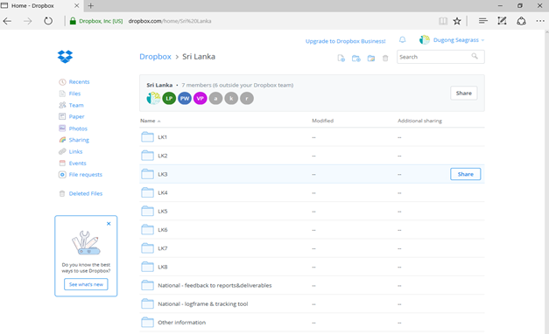

After selecting your project ID (LK2 in this example), you will enter the project folder and will see the following content:
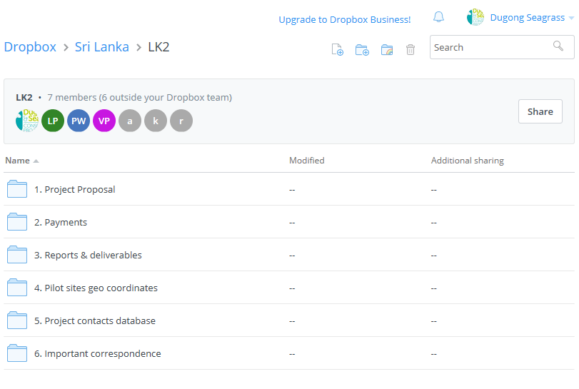
To see your original concept of 2013 and the recommendations by DTG and/ or to see your final proposal and comments by PCT, click on folder “1.Project Proposal”. Following this, you will see the following content.
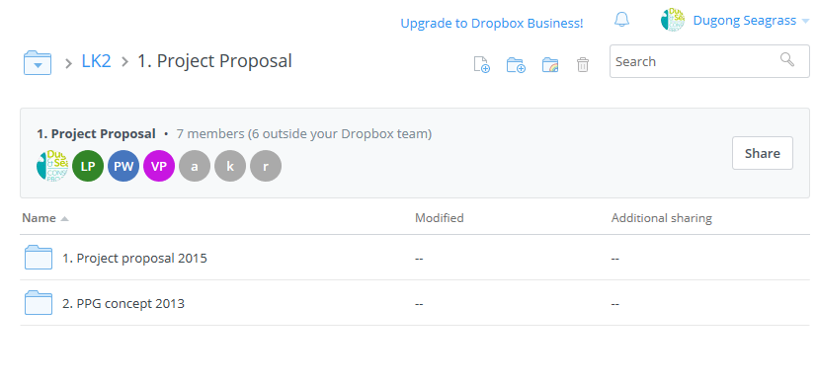
The content below will open when you click on folder “2. Payments”. The content will vary based on how many cash advance requests have been approved by PCT. If you see missing approved cash advance requests, please add them to this folder.
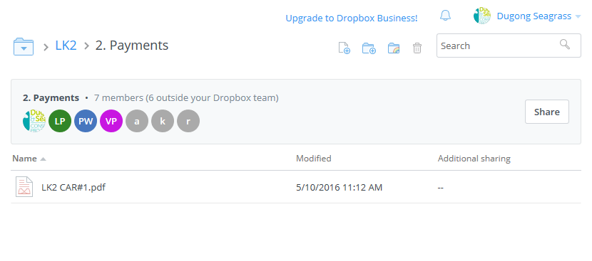
This is what Dropbox will display, when you click on folder “3. Report&deliverables”. This is a very important folder – all technical and financial progress reports are and will be uploaded here.
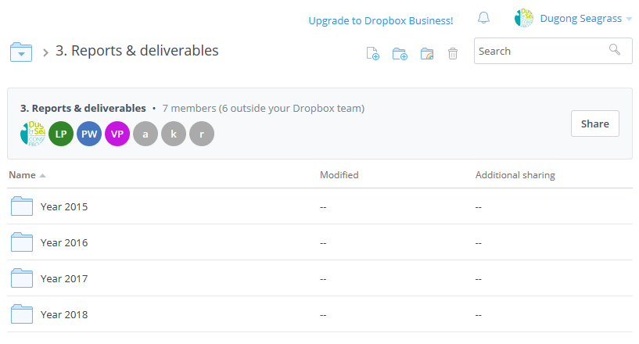
The next window shows the content of “Year 2016”, which is identical to the content of all other year folders.
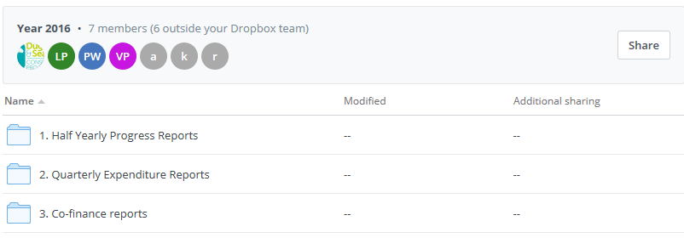
Going further and opening sub-folder “1. Half-yearly Progress Reports” will open two sub-folders, according to the periods of reporting on progress (Jan-Jun and Jul-Dec of the year).
PCT uploaded all available information about progress reports for the period Jan-Jun 2016.
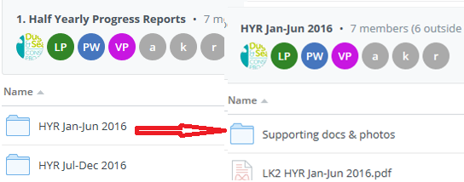

The next reports on progress and supporting documents for the period Jul-Dec 2016 are expected to be reported by Partners in folder “HYR Jul-Dec 2016”. For the convenience of all partners and PCT, it is recommended to upload the supporting documents related to future half-yearly progress reports (starting from Jul-Dec 2016) as soon as they are ready.
To access existing quarterly expenditure reports or upload upcoming reports, the Partners should access the folder “2. Quarterly Expenditure Report” located in the year folder (“Year 2016”, for example), then to select the reporting period they want to upload information about, as shown below.
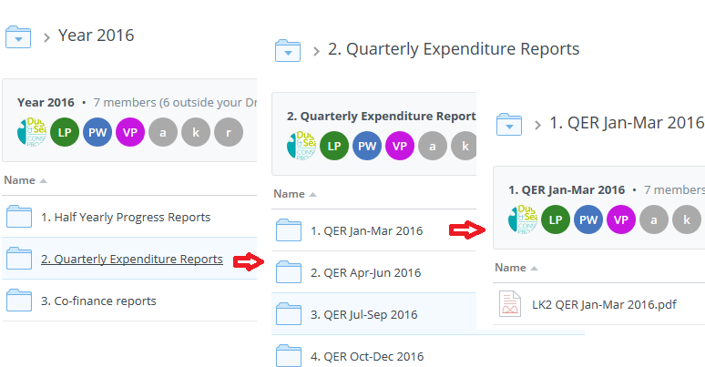

The path for co-finance reports is similar.

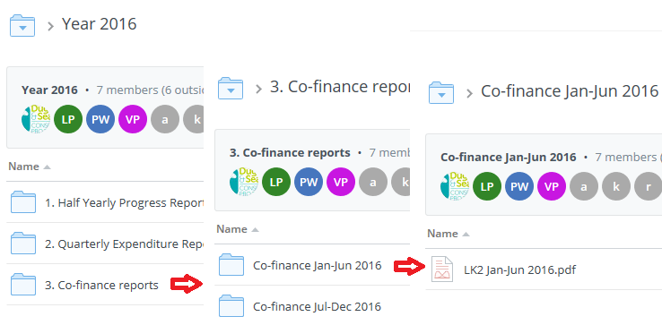
Step 3. Inform PCT about any changes done by editors (Project Partners’ team members who have been given editing rights)
Once done editing the content of your country/ project folder, please advise PCT members, Maya Todorova, mbankova@mbzfund.org and Mariam Yacout, myacout@mbzfund.org

- When should we start using the repository?
The virtual repository was launched on 5 Oct 2016 and is available for use of Partners immediately. PCT advised that quarterly expenditure reports for the period Jul-Sep 2016 should already be uploaded directly by partners to the respective sub-folder.

- What are the next steps?
All Partners should review their content and upload any missing information to existing reports/ content. All future reports will be shared with PCT using the Project virtual repository.
PCT will add a global Project folder containing the global Project reports, linking them to the individual reports of the Project Partners.

